Experiment-2

AIM: Design Christmas LED chaser light.

APPARATUS: Connecting wires, resistances, Arduino, LED(s).

CIRCUIT DIAGRAM:

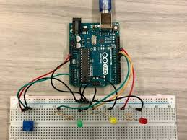

THEORY:-

1. 8 Chasing of led a pattern of led glowing using breadboard and Arduino.

2. Arduino consist of both a physical programmable circuit board and a piece of software or LDE that runs on your computer, used to write and upload computer code to the physical board which is the most realible feature of it and allows to easily access any kind of pattern in LED’s.

3.Digital signals provides the LED’s to run the same pattern as encoded by us in IOE.

LEARNING AND OBSERVATIONS:-

1.This is the perfect application of how hardwares and softwares together combines and can give rise to new ideas.

2.Working of Arduino board is well explanatory digital and analog connections are explanatory.

OBSERVATIONS:- Before uploading the code we need to confirm that the port is properly selected ,if not code will not be uploaded and circuit will not work. The LED’s will glow only if the digital signals are passed through the Arduino.

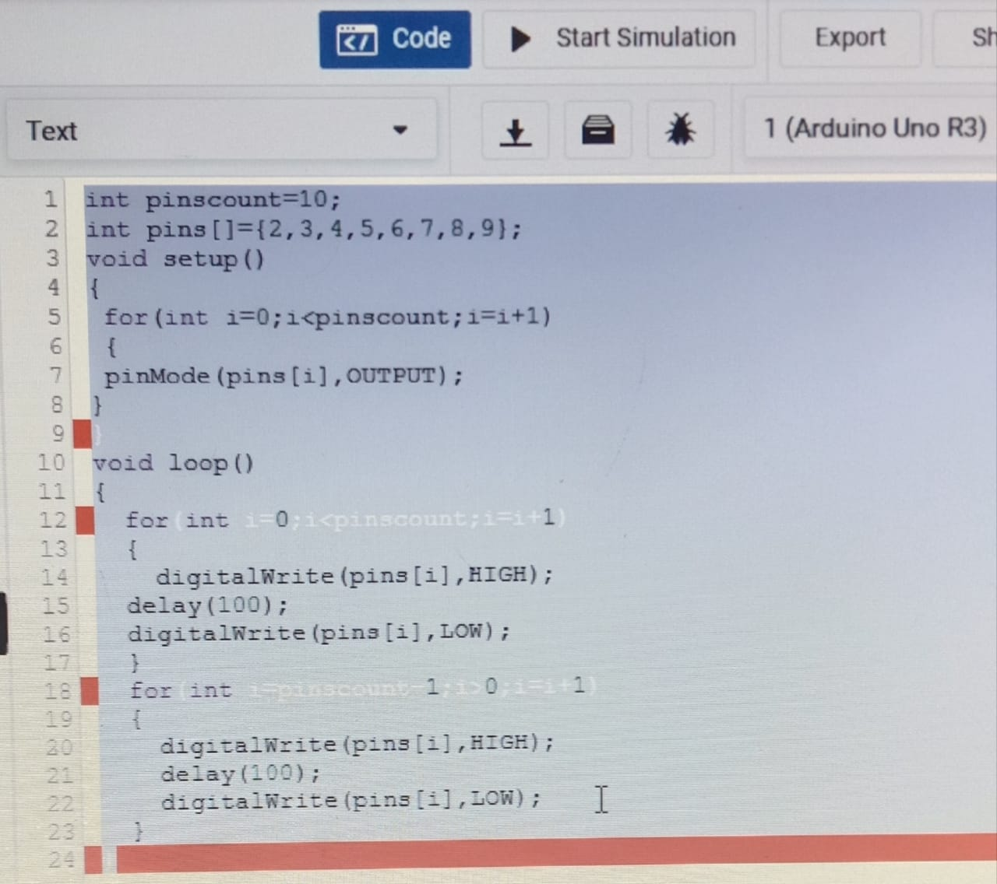

LEARNING OUTCOMES:-

1. Connections of all the components together and then a working circuit by programming the particular pattern we want to run in the circuit.

2. It helped me to enchance my coding /programming ability and developed the base of electronics using hardwares and softwares.

PROBLEMS AND TROUBLESHOOTING:-

1. Port was not selected appropriately and so code was not uploaded and circuit initially did not worked.

2. As I tried to switch the pattern in which LED’s were glowing . LED’s initially were glowing in the same pattern to run the new code reset button on Arduino helped to come out with such problem.

PRECAUTIONS:

1. All the connections should be checked properly. Wires should not be loose.

2. LED should not be fuse.

3. Port should be select properly.